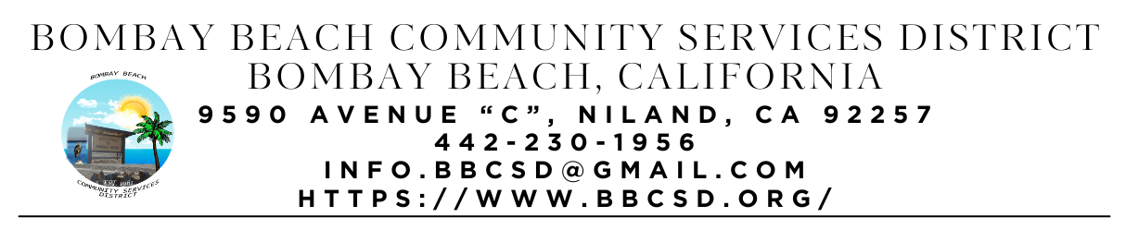

**REGULAR SCHEDULED MEETING AGENDA**

**Board of Directors**

Paedrin Fusco – Board Chair Date: FEBRUARY 20, 2025

Cameron Leslie – Vice Chair Time: CLOSED - 5:00 PM

Teresa Lamer OPEN – 6:00 PM

Steven Johnson Place: 9590 Avenue C

Niland, CA 92257

1. **CALL TO ORDER:** 
   1. Pledge Allegiance to the Flag
   2. Roll Call to determine Quorum
2. **APPROVAL OF THE AGENDA:** Board will approve the agenda for the Regular Meeting for February 20, 2025, as is or delete/clarify any item on the agenda.
3. **APPROVAL OF THE MEETING MINUTES:** Board will approve the Minutes for the Special Called Meeting on February 11, 2025, as is or delete/clarify any item on the minutes.
4. **CALL TO ENTER CLOSED SESSION:**
5. **CLOSED SESSION:**
   1. Conference with Real Property Negotiator (Gov’t Code section 54956.8) Re: Rental agreement for property on Bombay North (American Legion Post 801)
   2. Public employment (Gov’t code section 54957). Re: Temporary ERU Admin Consultant/Coordinator
   3. Public employment (Gov’t code section 54957). Re: District Accountant
6. **CALL TO RETURN TO OPEN SESSION:**
   1. Pledge Allegiance to the Flag
7. **CONSENT AGENDA:** “A Consent Agenda may be presented by the Board President at the beginning of a meeting. Items may be removed from the Consent Agenda on the request of any one member. Items not removed may be adopted by general consent without debate. Removed items may be taken up either immediately after the consent agenda or placed later on the agenda at the direction of the assembly”.
   1. FINACIAL REPORT: Report on financial status of the District as of December 31, 2025
      1. Bank of America Account Ending in 1946 - $356.86
      2. Bank of America Account Ending in 6398 - $4,666.70
      3. Bank of America Account Ending in 8860 - $821.37
      4. Bank of America Account Ending in 9163 - $819.80
      5. 5 Star Account Ending in – Haven’t attained Access Yet
      6. 5 Star Account Ending in -Haven’t attained Access Yet
      7. Total Amount of District Funds in BofA Accounts - $6,664.73
   2. The Board will approve payment of accounts payable in the form of Demands to the County. Copy of list of Demands is available upon request.
   3. The process to establish an Emergency Response Unit. (ERU Admin)
   4. What to do with the Large Water Pump that belongs to the District. (ERU Admin)
   5. The Board will consider adopting resolution 2024-01-01 Uniform Public Construction Cost Accounting Act. (Youngberg) (Item introduced 09/13/2023)
   6. The Board will hear an update on the establishment of a local mass texting or information dissemination service for Bombay Beach Residents. . (Youngberg - Assumed responsibility 12/19/24)
   7. The Board will hear an update and discuss the offers for the Districts Fire Apparatus listed on GovDeals for sale/auction. (Youngberg).
8. **OPEN FORUM/PUBLIC COMMENT:** This is an opportunity for members of the public to address the Board on any subject matter within the Board’s jurisdiction, but not an item on the published agenda. Public Comment on agenda items will be allowed when the agenda item is called by the Board. Please make comments at podium, state name and limit comments to 3 minutes.
9. **ITEMS REMOVED FROM CONSENT AGENDA:**
10. **OLD BUSINESS – DISCUSSION/ACTION ON THE FOLLOWING:**
    1. The Board will hear an update on Constructing a fence to separate the trash dumpsters lot from the adjoining lot. (Youngberg) (Item introduced 06/15/2023)
    2. The Board will hear an update on Park Grant (Youngberg)
    3. The Board will hear an update on District Kitchen Remodel Project. (Youngberg)
    4. The Board will hear an update on Process to Acquire the Fire Department Building at Bombay Beach. (Fusco)
    5. The Board will hear an update on the Process to establish a Flood Response Unit for Bombay Beach. (Youngberg/Fusco)
    6. The Board will hear an update on the Avenue A Beautification Update. (Youngberg)
    7. The Board will hear an update on If continuing use of District supplied cell phone service is still required. (Lamer)
    8. The Board will hear an update on Looking at other payroll agencies to provide District Payroll Service. (Youngberg/Johnson) (Introduced 06/20/2024)
    9. The Board will hear an update on the process of renaming Avenue E to Ernie Street. (Czar/Youngberg) (Introduced 06/20/2024)
    10. The Board will provide an update on Applying for the EPA Thriving Communities Grant (Fusco/Youngberg) (Introduced 01/16/2025)
    11. Board will hear an update on the Removal of fence in front of the park area along Avenue C to make it more welcoming and accessible to residents and visitors (Fusco/Youngberg) (Introduced 01/16/2025)
    12. Board will hear an update on Building a fenced in Dog Park Area for visitors to the Park and Community Center (Fusco/Youngberg)(Introduced 01/16/2025)
    13. The Board will hear an update on the Purchase and Installation of Security Camera System offered to the District by Junior (Introduced 01/16/2025)
    14. The Board will hear an update on Replacing and or repair of bulletin boards at each mailbox area in town for easier sharing of information (Introduced 01/16/2025)
11. **NEW BUSINESS – DISCUSSION/ACTION ON THE FOLLOWING:**
    1. The Board will discuss the Appointment of a new Director on the Bombay Beach Community Services District Board
       1. Swearing in of new Bombay Beach Community Services District Director
    2. The Board will provide a report from Closed Session (Fusco)
       1. Introduction of new District Accountant
       2. Introduction of Temporary ERU Admin Consultant/Coordinator
    3. The Board will provide an update about the Strategic Planning Meeting on February 11, 2025 (Fusco)
    4. Presentation by Valle Unido por Beneficios Comunitarios – Community Benefits Agreement
    5. Imperial Valley Film Commission here to discuss Concerns in Town regarding Filming with residents
12. **COMMUNITY REPORTS:**
    1. **Upcoming Events:**
       1. Transportation Survey
       2. Auggies AMF (Adios my Friend) Celebration of Life on Saturday Feb 22nd at the American Legion at 2pm and Ski Inn Patio at 4pm
13. **BOARD DISCUSSION/DIRECTIVES:**
14. **DIRECTOR REPORTS:**
15. **ADJOURNMENT:**