**BOMBAY BEACH COMMUNITY SERVICES DISTRICT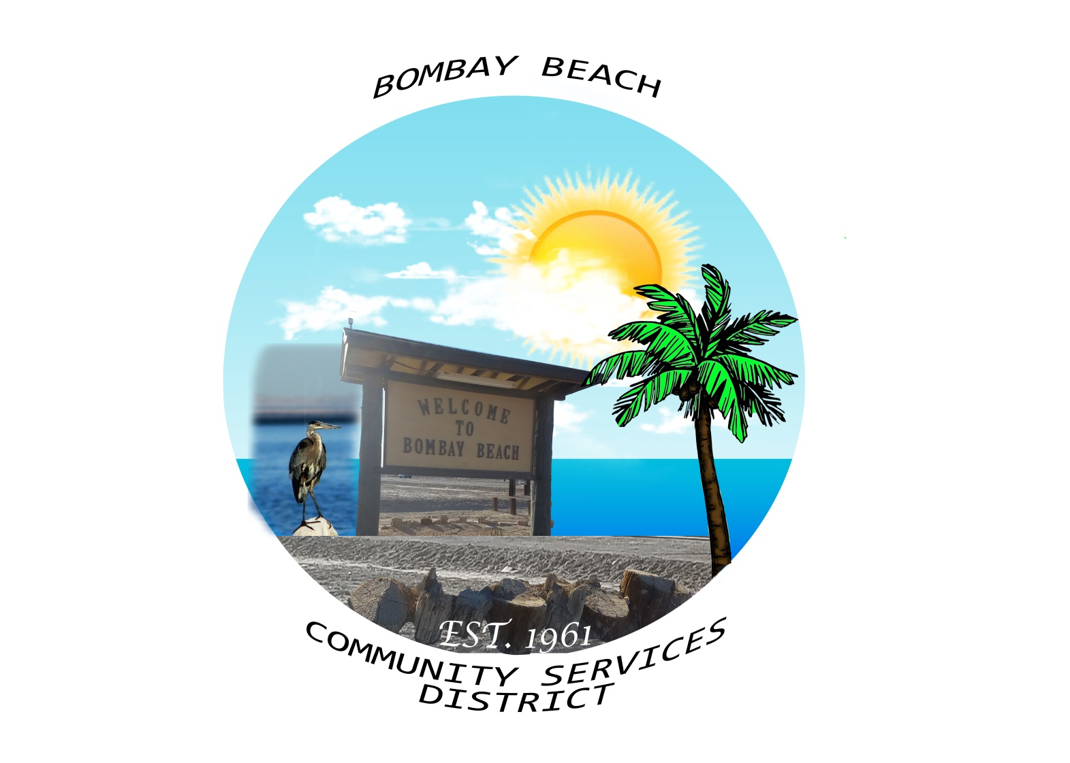 BOMBAY BEACH, CALIFORNIA**

9590 Avenue C, Niland, CA 92257

(760) 550-3264 or email:BombayBeach2015@gmail.com

https://bbcsd.org

**Special Called Meeting Agenda**

**Board of Directors**

Kimberly Hernandez - Chairperson Date: October 24, 2024

Paedrin Fusco – Vice Chair Time: 5:30 pm for closed session

Candace Youngberg 6:00 pm for open session

Cameron Leslie Place: 9590 Avenue C *Bombay Beach*

James Connelly Niland, CA 92257

1. CALL TO ORDER:

A. Pledge of Allegiance to the Flag.

B. Roll Call to determine a Quorum

1. APPROVAL OF THE AGENDA: The Board will approve the agenda for Special Meeting of October 24, 2024 as is or delete/clarify any item on the agenda.
2. The Board will go into CLOSED SESSION:
3. The Board will go into CLOSED SESSION. Public employee employment, appointment, or dismissal. (Gov’t Code Section 54957.)
4. CALL TO ORDER AND RETURN TO OPEN SESSION AT 6:00 PM:
5. OPEN FORUM /PUBLIC COMMENT: This is an opportunity for members of the public to address the Board on any subject matter within the Board’s jurisdiction, but not an item on the agenda. Any action taken as a result of public comment shall be limited to direction to staff. (Please Limit Comments to 3 Minutes per speaker and to 30 minutes limit for open forum) (Each speaker is requested to voluntarily provide their name and residence prior to speaking)
6. NEW BUSINESS – DISCUSSON/ACTION ON THE FOLLOWING:
7. The Board will Announce District Vacancy and Give Report from Closed Session
8. Board will approve of payment of accounts payable in the form of demands to the county. Copy of list of demands is available upon request.
9. ADJOURNMENT: