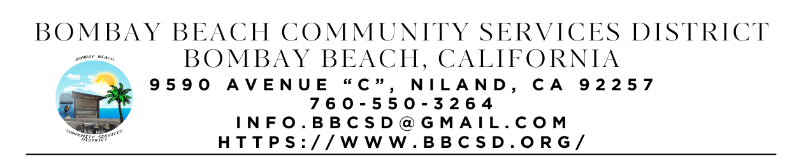

**SPECIAL CALLED MEETING AGENDA**

**Board of Directors**

Paedrin Fusco – Board Chair Date: Feb 11, 2025

Cameron Leslie – Vice Chair Time: 1:00 PM

Theresa Lamer Place: 9590 Avenue C Bombay Beach

Steven Johnson Niland, CA 92257

1. **CALL TO ORDER:** 
   1. Pledge Allegiance to the Flag
   2. Roll Call to determine Quorum
2. **APPROVAL OF THE AGENDA:** Board will approve the agenda for the Special Called Meeting for February 11, 2025, as is or delete/clarify any item on the agenda.
3. **APPROVAL OF MEEING MINUTES:** Board will approve the meeting minutes from Special called meeting on January 23, 2025.
4. **NEW BUSINESS – DISCUSSION/ACTION ON THE FOLLOWING:**
   1. Strategic Planning and Vision workshop with Roque Barros From IV Wellness Foundation
5. **OPEN FORUM/PUBLIC COMMENT:** This is an opportunity for members of the public to address the Board on any subject matter within the Board’s jurisdiction, but not an item on the published agenda. Public Comment on agenda items will be allowed when the agenda item is called by the Board. Please make comments at podium, state name and limit comments to 3 minutes.
6. **COMMUNITY REPORTS:**
7. **BOARD DISCUSSION/DIRECTIVES:**
8. **DIRECTOR REPORTS:**
9. **ADJOURNMENT:**