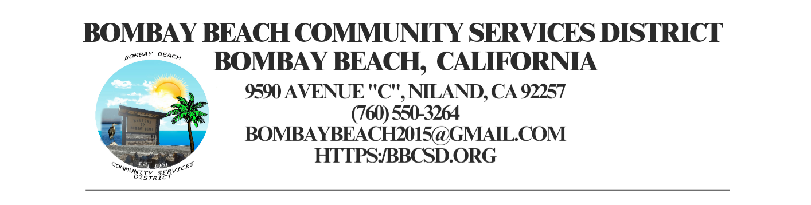

**Special Called Meeting Minutes**

**Board of Directors**

Kimberly Hernandez - Chairperson Date: October 24, 2024

Paedrin Fusco – Vice Chair Time: 5:30 pm for closed session

Candace Youngberg 6:00 pm for open session

Cameron Leslie Place: 9590 Avenue C *Bombay Beach*

James Connelly Niland, CA 92257

1. CALL TO ORDER:
2. Called to order by: Director Hernandez at 5:33pm

A. Pledge of Allegiance to the Flag.

B. Roll Call to determine a Quorum: Quorum Established: 4 out of 5 Directors Present

a. Director Hernandez: Present

b. Director Fusco: Present

c. Director Youngberg: Present

d. Director Leslie: Present

e. Director Connelly: *Arrived at 6:00pm*

1. APPROVAL OF THE AGENDA: The Board will approve the agenda for Special Meeting of October 24, 2024 as is or delete/clarify any item on the agenda.
2. Motion to approve made by: Director Leslie
3. Seconded by: Director Hernandez
4. Vote: 4-0-0
5. The Board will go into CLOSED SESSION:

Motion to go into closed session made by: Director Hernandez at 5:34pm

1. The Board will go into CLOSED SESSION. Public employee employment, appointment, or dismissal. (Gov’t Code Section 54957.)
2. Advice from Mr. Driskill – Appoint someone to act as Secretary/Clerk of the Board interim. Person appointed will only act as Secretary/Clerk of the Board until Auggie returns or Dec. 31, 2024 when the new hire takes over. This is only a temporary short term appointment. The person appointed can still vote on agenda items unless it is a conflict of interest, example person appointed submits application for the Auggie’s position.
3. Direction from Director Fusco to add: Discuss Suing Kitchen Contractor JW Supreme Solutions to Nov 21st 2024 agenda for closed session.
4. CALL TO ORDER AND RETURN TO OPEN SESSION AT 6:00 PM:

Called to Order by: Director Hernandez at 6:03pm

1. OPEN FORUM /PUBLIC COMMENT:
2. Member of the public announced a Community Clean Up Saturday Nov. 23rd 2024 8am-12pm
3. Member of the public announced Rabies/Dog Shots Clinic will be Sunday Nov 24th 2024 2:30pm-3:30pm
4. Member of the public notified the board that a street light is not working on the corner of Avenue H and 3rd Street
5. Member of the public asked if the trash hours are going to change
6. Direction by Director Fusco to add – Discussion of Trash Hours to the Nov 21st 2024 Agenda

NEW BUSINESS – DISCUSSON/ACTION ON THE FOLLOWING:

1. The Board will Announce District Vacancy and Give Report from Closed Session
2. Announcement Made By: Director Hernandez
3. Announcement: Auggie will not be available until further notice. Motion to appoint Director Youngberg as Interim Secretary/Clerk of the Board made by Director Fusco. Seconded by Director Hernandez Vote: 4-0-0
4. Board will approve of payment of accounts payable in the form of demands to the county. Copy of list of demands is available upon request.
5. Motion to Approve made by: Director Fusco
6. Seconded by: Director Hernandez
7. Vote: 5-0-0

7. ADJOURNMENT:

a. Motion to Adjure Made By: Director Hernandez at 6:22pm

