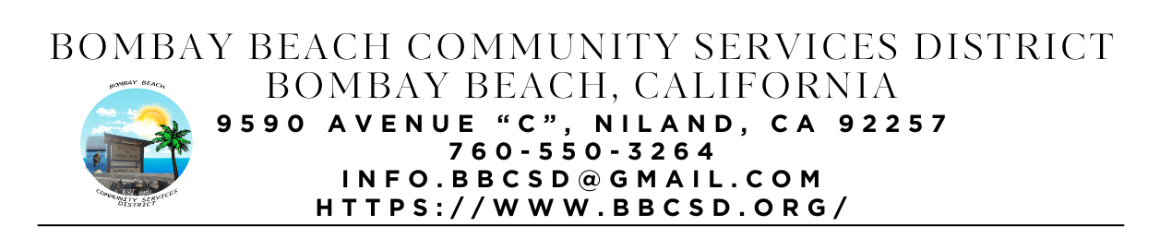

**REGULAR SCHEDULED MEETING AGENDA**

**Board of Directors**

Paedrin Fusco – Board Chair Date: January 16, 2025

Candace Youngberg – Vice Chair Time: CLOSED - 5:00 PM

Cameron Leslie OPEN – 6:00 PM

Teresa Lamer Place: 9590 Avenue C Bombay Beach

Steven Johnson Niland, CA 92257

1. **CALL TO ORDER:** 
   1. Pledge Allegiance to the Flag
   2. Roll Call to determine Quorum
2. **APPROVAL OF THE AGENDA:** Board will approve the agenda for the Regular Meeting for January 16, 2025, as is or delete/clarify any item on the agenda.
3. **CLOSED SESSION:**
   1. Conference with Real Property Negotiator (Gov’t Code section 54956.8) Re: Rental agreement for property on Bombay North (American Legion Post 801)
   2. Conference with Real Property Negotiator (Gov’t Code section 54956.8) Re: Rental agreement for property on Bombay North (Ascension) (Robin/Director Johnson)
   3. Public employment (Gov’t code section 54957). Re: Stipend for Job Training as part of grant requirements
   4. Public employment (Gov’t code section 54957). Re: Secretary/Clerk of the Board Position
4. **APPROVAL OF MEETING MINUTES FROM December 19, 2024:**
5. **CONSENT AGENDA:** “A Consent Agenda may be presented by the Board President at the beginning of a meeting. Items may be removed from the Consent Agenda on the request of any one member. Items not removed may be adopted by general consent without debate. Removed items may be taken up either immediately after the consent agenda or placed later on the agenda at the direction of the assembly”.
   1. FINACIAL REPORT: Report on financial status of the District as of December 31, 2024. Still Pending Access to all Accounts
   2. The Board will approve payment of accounts payable in the form of Demands to the County. Copy of list of Demands is available upon request.
   3. The process to establish an Emergency Response Unit. (ERU Admin)
   4. What to do with the Large Water Pump that belongs to the District. (ERU Admin)
   5. The Board will consider adopting resolution 2024-01-01 Uniform Public Construction Cost Accounting Act. (Youngberg) (Item introduced 09/13/2023)
   6. The Board will hear an update on the establishment of a local mass texting or information dissemination service for Bombay Beach Residents. . (Youngberg - Assumed responsibility 12/19/24)
   7. The Board will hear an update and discuss the offers for the Districts Fire Apparatus listed on GovDeals for sale/auction. (Youngberg).
   8. The Board will discuss the purchase of a water bowser or like option for the ERU to assist with Fire Suppression. (ERU Admin)
6. **OPEN FORUM/PUBLIC COMMENT:** This is an opportunity for members of the public to address the Board on any subject matter within the Board’s jurisdiction, but not an item on the published agenda. Public Comment on agenda items will be allowed when the agenda item is called by the Board. Please make comments at podium, state name and limit comments to 3 minutes.
7. **ITEMS REMOVED FROM CONSENT AGENDA:**
8. **OLD BUSINESS – DISCUSSION ACTION ON THE FOLLOWING:**
   1. The Board will hear an update to construct a fence to separate the trash dumpsters lot from the adjoining lot. (Youngberg) (Item introduced 06/15/2023)
   2. Board will hear an update on Park Grant (Youngberg)
   3. District Kitchen Remodel Project. (Youngberg)
   4. The Process to Acquire the Fire Department Building at Bombay Beach. (Fusco)
   5. The Process to establish a Flood Response Unit for Bombay Beach. (Youngberg/Fusco)
   6. Avenue A Beautification Update. (Youngberg)
   7. The Board will discuss if continuing use of District supplied cell phone service is still required. (Lamer)
   8. The Board will discuss looking at other payroll agencies to provide District Payroll Service. (Introduced 06/20/2024)
   9. The Board will discuss the process of renaming Avenue E to Ernie Street. (Czar/Youngberg) (Introduced 06/20/2024)
9. **NEW BUSINESS – DISCUSSION/ACTION ON THE FOLLOWING:**
   1. Board will provide a report from Closed Session (Fusco)
   2. Board will make an announcement about the Trust for Civic Life Grant awarded to the Bombay Beach Community Services District (Fusco)
   3. Board will discuss using part of the Trust for Civic Life Grant allocated for the ERU to pay for a Temporary Admin Position to assist Volunteer Admins with getting things up and running. (Fusco).
   4. Board will discuss hiring an Accountant to help with District Finances. (Fusco)
   5. Board will discuss and volunteer for Standing Committees
   6. Board will discuss and decide on 2 Directors to be added as signers for the BofA General Fund Account
   7. Board will discuss the purchase of lighting used for the Legends Fundraiser on January 1st from Brenda to add to the District supplies for events.
   8. Board will discuss how much funds will be allocated to the Valentine’s Day Party on February 14th.
   9. Board will discuss attending upcoming Leadership Academy in La Quinta April 21 – 25, 2025
   10. Board will discuss removal of fence in front of the park area along Avenue C to make it more welcoming and accessible to residents and visitors (Fusco)
   11. Board will discuss building a fenced in Dog Park Area for visitors to the Park and Community Center (Fusco)
   12. Board will discuss applying for the EPA Thriving Communities Grant (Fusco)
   13. Board will discuss the Purchase and Installation of Security Camera System offered to the District by Junior
   14. Board will discuss replacing and or repair of bulletin boards at each mailbox area in town for easier sharing of information.
10. **COMMUNITY REPORTS:**
    1. **Upcoming Meetings:**
       1. Lithium Valley Town Hall - January 23rd - 6pm-8pm at 150 W Main Street, Calipatria Ca
       2. Salton Sea CEQA Scoping Meeting – January 23rd – 6pm-8pm – North Shore Yacht Club – 99155 Sea View Drive, Mecca CA
       3. Health and Wellness Fair host by Bombay Beach ECO Group February 12th
11. **BOARD DISCUSSION/DIRECTIVES:**
12. **DIRECTOR REPORTS:**
13. **ADJOURNMENT:**