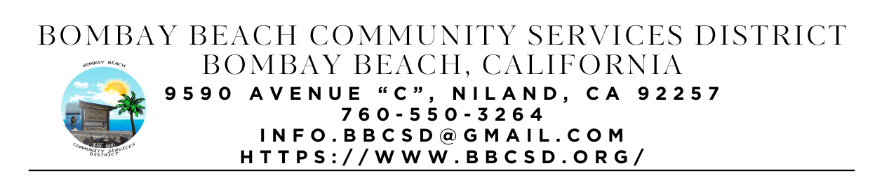

**SPECIAL CALLED MEETING AGENDA**

**Board of Directors**

Paedrin Fusco – Board Chair Date: January 23, 2025

Cameron Leslie – Vice Chair Time: 1:00 PM

Theresa Lamer Place: 9590 Avenue C Bombay Beach

Steven Johnson Niland, CA 92257

1. **CALL TO ORDER: Meeting called to Order by Director Fusco at 1:17pm**
   1. Pledge Allegiance to the Flag
   2. Roll Call to determine Quorum
      1. Director Fusco – Present
      2. Director Leslie – Absent
      3. Director Lamer – Present
      4. Director Johnson – Present
      5. Quorum Established 3 out of 4 Directors Present
2. **APPROVAL OF THE AGENDA:** Board will approve the agenda for the Special Called Meeting for January 23, 2025, as is or delete/clarify any item on the agenda.
   1. Motion to approve agenda made by Director Johnson
   2. Seconded by director Lamer
   3. Vote: 3-0-0
3. **OPEN FORUM/PUBLIC COMMENT:** This is an opportunity for members of the public to address the Board on any subject matter within the Board’s jurisdiction, but not an item on the published agenda. Public Comment on agenda items will be allowed when the agenda item is called by the Board. Please make comments at podium, state name and limit comments to 3 minutes.
4. **NEW BUSINESS – DISCUSSION/ACTION ON THE FOLLOWING:**
   1. Board will discuss purchase of water bowser for ERU
      1. Motion to approve purchase of 500 gal qwater bowser for ERU made by Director Fusco
      2. Seconded by Director Lamer
      3. Vote: 3-0-0
   2. Capacity Building Workshop with Roque Barros From IV Wellness Foundation
      1. Notes: See attached pictures.
      2. Discussed Values we would like to see in Bombay Beach. Each Director names five values as well as the Secretary.
         1. Director Johnson: Community, Leadership, Citizenship, Knowledge, Compassion
         2. Director Fusco: Tenacity, Authenticity, Respect, Creativity, Fun
         3. Director Lamer: Community, Growth, Balance, Enjoyment, Success
         4. Secretary Youngberg: Community/Belonging, Inner Harmony, Groth, Meaningful Work/Service, Stability
      3. Discussed how to run the next workshop on February 11th
         1. Ask public what they L:ike, Don’t Like, and Would Change
         2. Ask p[public about what they would like to see in the future compared to our list
         3. Make a plan for things to get done in the next 90 days
      4. Discussed job duties and skill for ERU Admin Coordinator Position
5. **COMMUNITY REPORTS:** BBAC Feast Saturday at 3pm, Kids Club Selling Lemonade during feast
6. **BOARD DISCUSSION/DIRECTIVES:**
7. **DIRECTOR REPORTS:**
8. **ADJOURNMENT:** Director Fusco Adjourned meeting at 2:56pm

