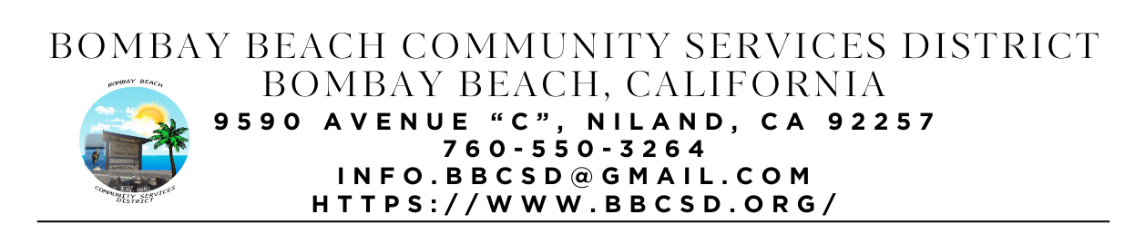

**SPECIAL CALLED MEETING AGENDA**

**Board of Directors**

Paedrin Fusco – Board Chair Date: January 23, 2025

Cameron Leslie – Vice Chair Time: 1:00 PM

Theresa Lamer Place: 9590 Avenue C Bombay Beach

Steven Johnson Niland, CA 92257

1. **CALL TO ORDER:** 
   1. Pledge Allegiance to the Flag
   2. Roll Call to determine Quorum
2. **APPROVAL OF THE AGENDA:** Board will approve the agenda for the Special Called Meeting for January 23, 2025, as is or delete/clarify any item on the agenda.
3. **OPEN FORUM/PUBLIC COMMENT:** This is an opportunity for members of the public to address the Board on any subject matter within the Board’s jurisdiction, but not an item on the published agenda. Public Comment on agenda items will be allowed when the agenda item is called by the Board. Please make comments at podium, state name and limit comments to 3 minutes.
4. **NEW BUSINESS – DISCUSSION/ACTION ON THE FOLLOWING:**
   1. Board will discuss purchase of water bowser for ERU
   2. Capacity Building Workshop with Roque Barros From IV Wellness Foundation
5. **COMMUNITY REPORTS:**
6. **BOARD DISCUSSION/DIRECTIVES:**
7. **DIRECTOR REPORTS:**
8. **ADJOURNMENT:**